**CW6 GUI**

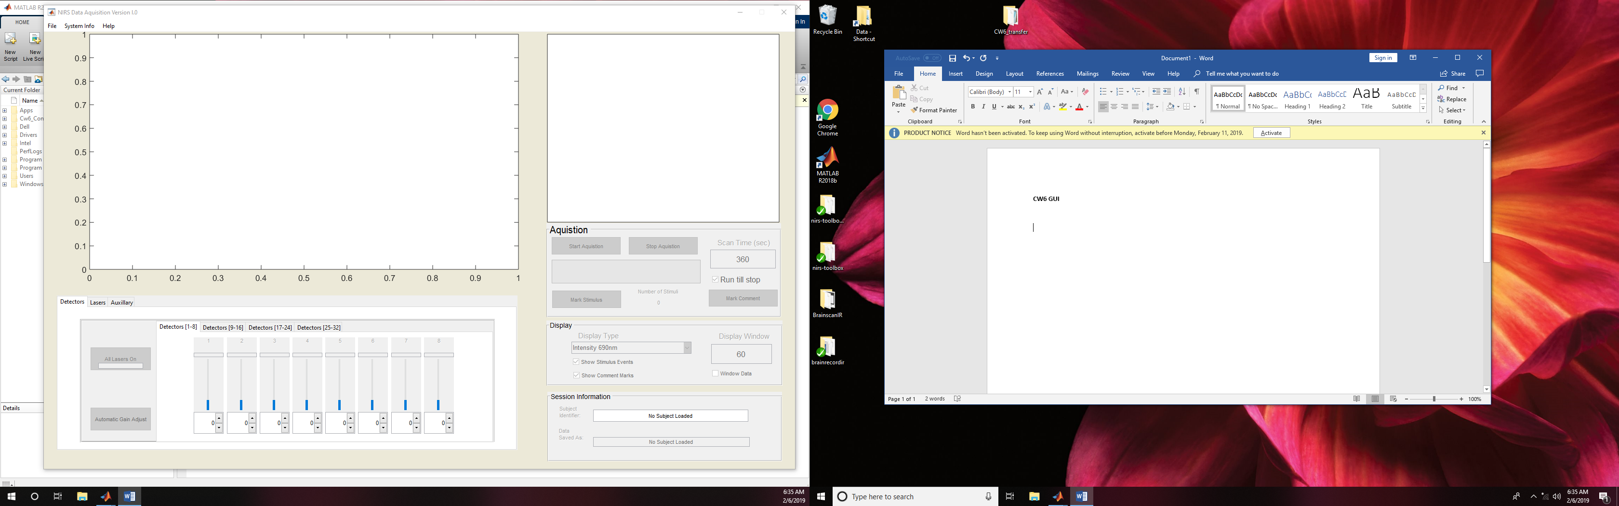

1. When first launching the GUI, it should open as shown above. If you get a warning popup message about failure to load the CW6, check that the instrument power is on and the USB cable is connected. If needed, check in device manager, that the FTDI driver was found (it should show up in the COM ports when the Cw6 is plugged in and on)
2. Before you can do anything, you need to “Register New Subject”. Using the pulldown menu on the top of the GUI File/Subject/Register Subject (also hotkeyed as Ctrl-N)

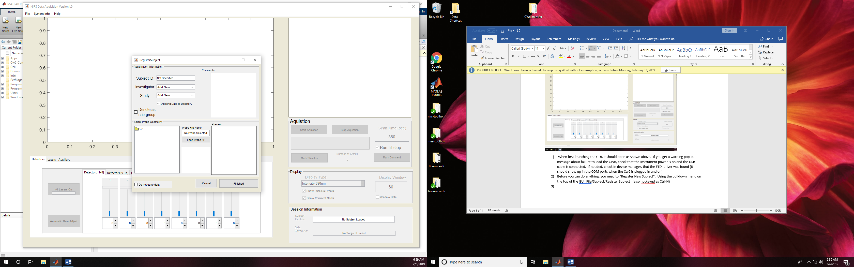

From the Investigator and Study pull downs select your study. These options are set based on the data folder location. (E.g. C:\CW6_Control\Data) If this is empty or does not show the investigators, refer to the installation document. Selecting an investigator will update the list of studies for that investigator (subfolders to the investigator folder). Selecting a study should load a preview of the probe and any comments in the SDG file.

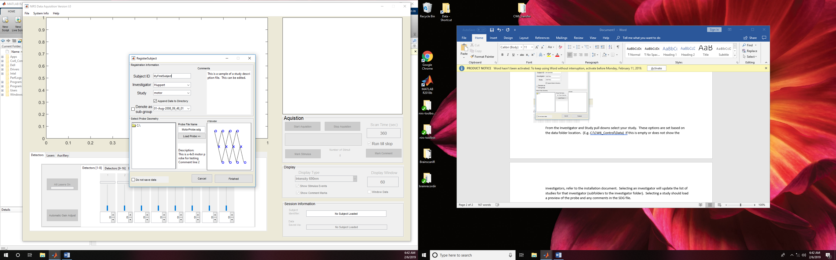

Enter the subject ID in the edit box. If you forget to do this, a warning message is given when you try to finish.

The “Load probe” button can be used to override the default probe in the study folder

By default, the data will be dated in the C:\Cw6_Control\Data\<Investigator>\<Study>\<Subject ID_<Date> folder. The denote as sub-group button will add an extra folder layer (\Study\Sub-group\Subject). I don’t use this option much. T

The “do not save data” check box will avoid the automatic save option of the code. No subject ID is required if you have this checked. When recording, the data will not be automatically saved after each run (used mostly for testing). You can still save data manually if needed.

Click the “Finish” button once the data is entered. This should update the main GUI and close the register subject window.

Note- After registering the subject, the CW6 instrument will collect about 3-seconds of data to initialize and test everything.

2. Once the subject is registered all the GUI controls should become active

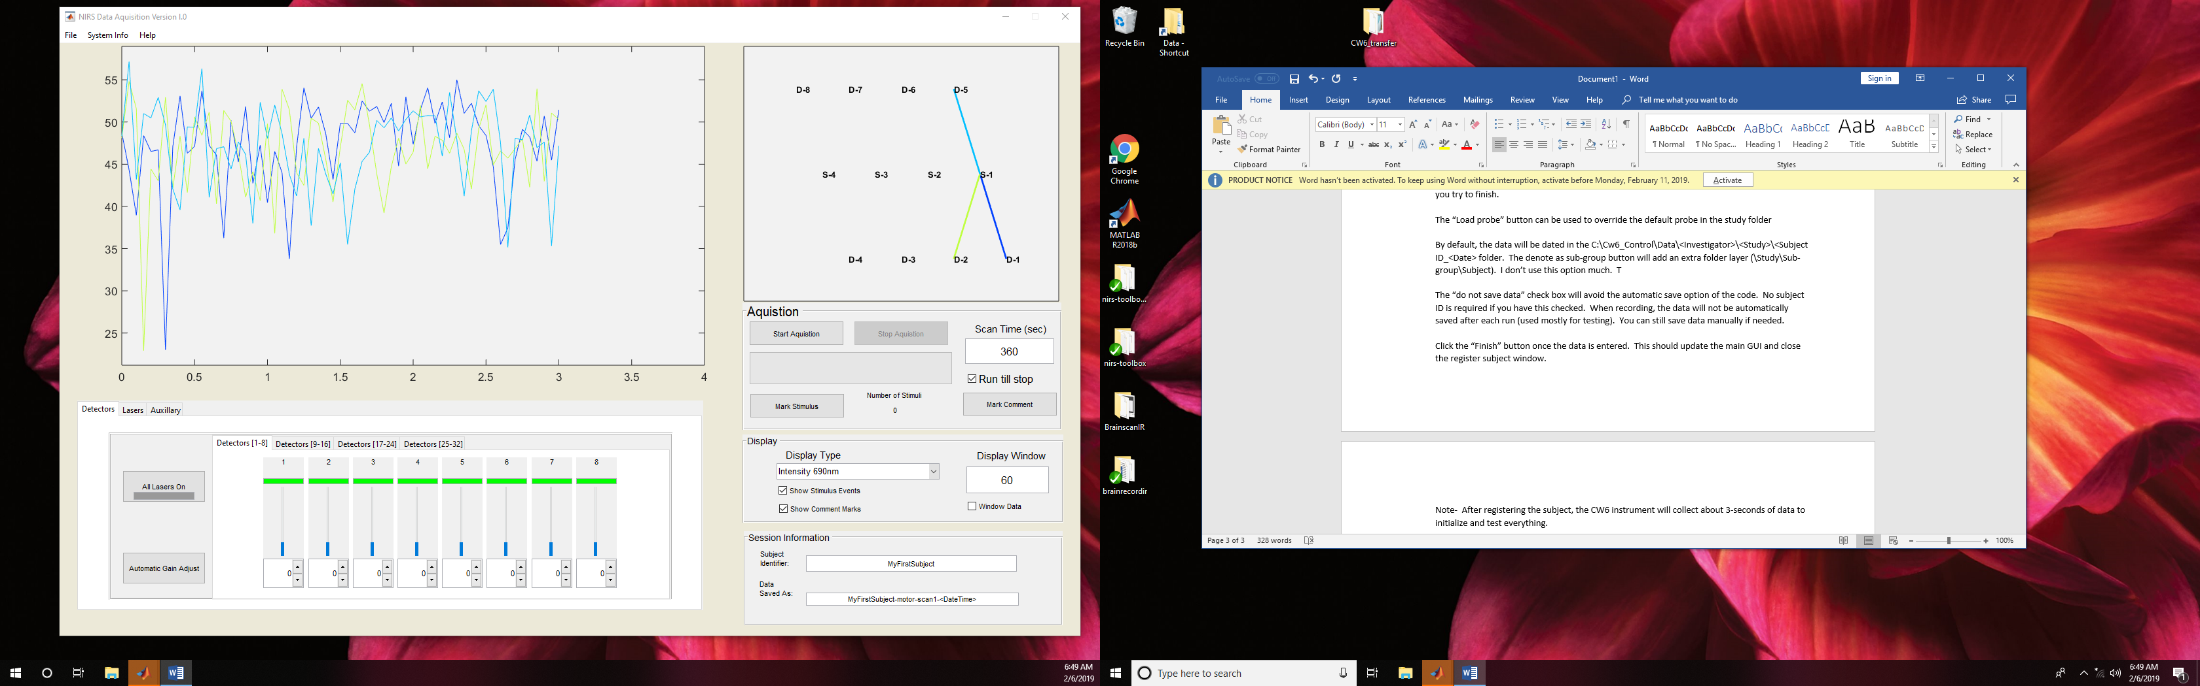

Buttons:

* The probe drawing on the upper right is interactive. The data shown is the measurements selected on the probe. Click on a source or detector to see the measurements from that optode. You can click on a line to toggle its visibility
* The “display type” pulldown allows you to change the wavelength etc
* Display window will window the time course to show only the last specified seconds of data and is useful for zooming in to see the cardiac cycle when setting up the study
* The show Stimulus and Show Comments check boxes will turn off the overlay of event marks on the time course window\
* The file name where the data will be stored and subject ID are shown in the “Session Information” field.
* If you Right-click on the Data Saved As textbox, you can manually save the data as a different file name
* The start/stop button is self explanatory.
* The scan time and run till stop checkbox control the maximum length of the data file. If the checkbox is true, the software will continue to run until you hit the stop button. Otherwise, the system will stop and save the data after the scan time.
* The mark stimulus and mark comments buttons are used to place manual event marks in the data. Comment marks are saved in the file, but not used by the HOMER or NIRS-toolbox code for analysis. Note- Once you mark stim or comments, you can right click on the event line (in the time-course window) and put text on the event (e.g. subject sneezed). Adding text works best if done after recording is over, but it does work in real-time
* The bottom right has the controls for the lasers/detectors. The All Lasers On/Off button turns on/off all the lasers used in this probe. Note, this does not change any laser that is not expected (based on the SDG file) to be used in the probe. The unused detector controls are also deactivated
* The automatic gain adjust button will attempt to set the detector gains based on the signal level (mostly works pretty ok, but still need to check the signals a bit)
* If you need to toggle a single laser, use the “Lasers” tab and buttons, but the “All on/off” is duplicated on all pages for easy access.
* The “Show auxillary” button on the last tab will plot the analog input channels on the CW6.
* Under the pulldown File>> Paradigm>> Mark Events you can launch a GUI with a few more buttons for manually marking stimulus events. The toggle check box changes if the control acts as a button (quick event mark) or a switch (on until it is turned off)

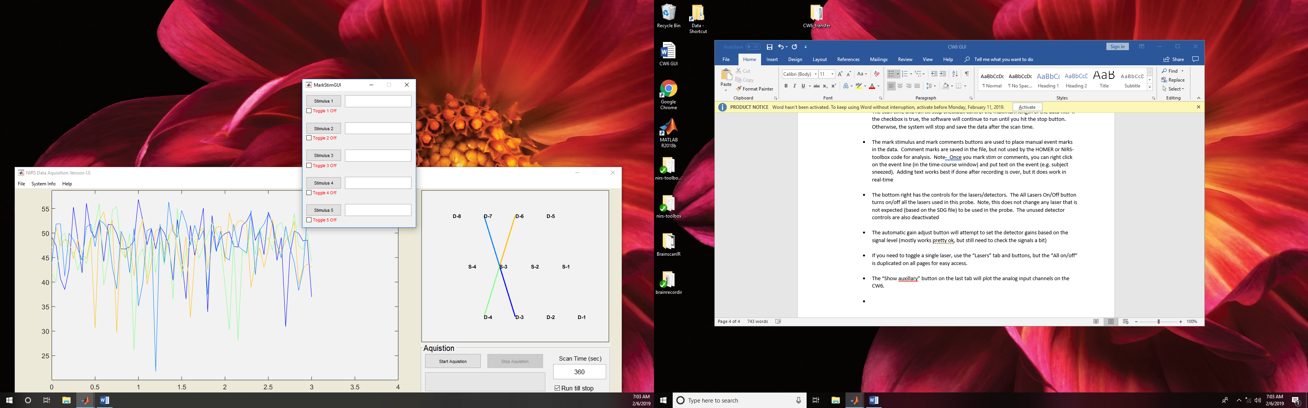

* The pulldown File>> Paradigm >> Setup Stimulus Channels launches a GUI that will allow you to change the names of stimulus events and auto-triggering from the analog input channels. By default only analog channel #1 is monitored for online triggers

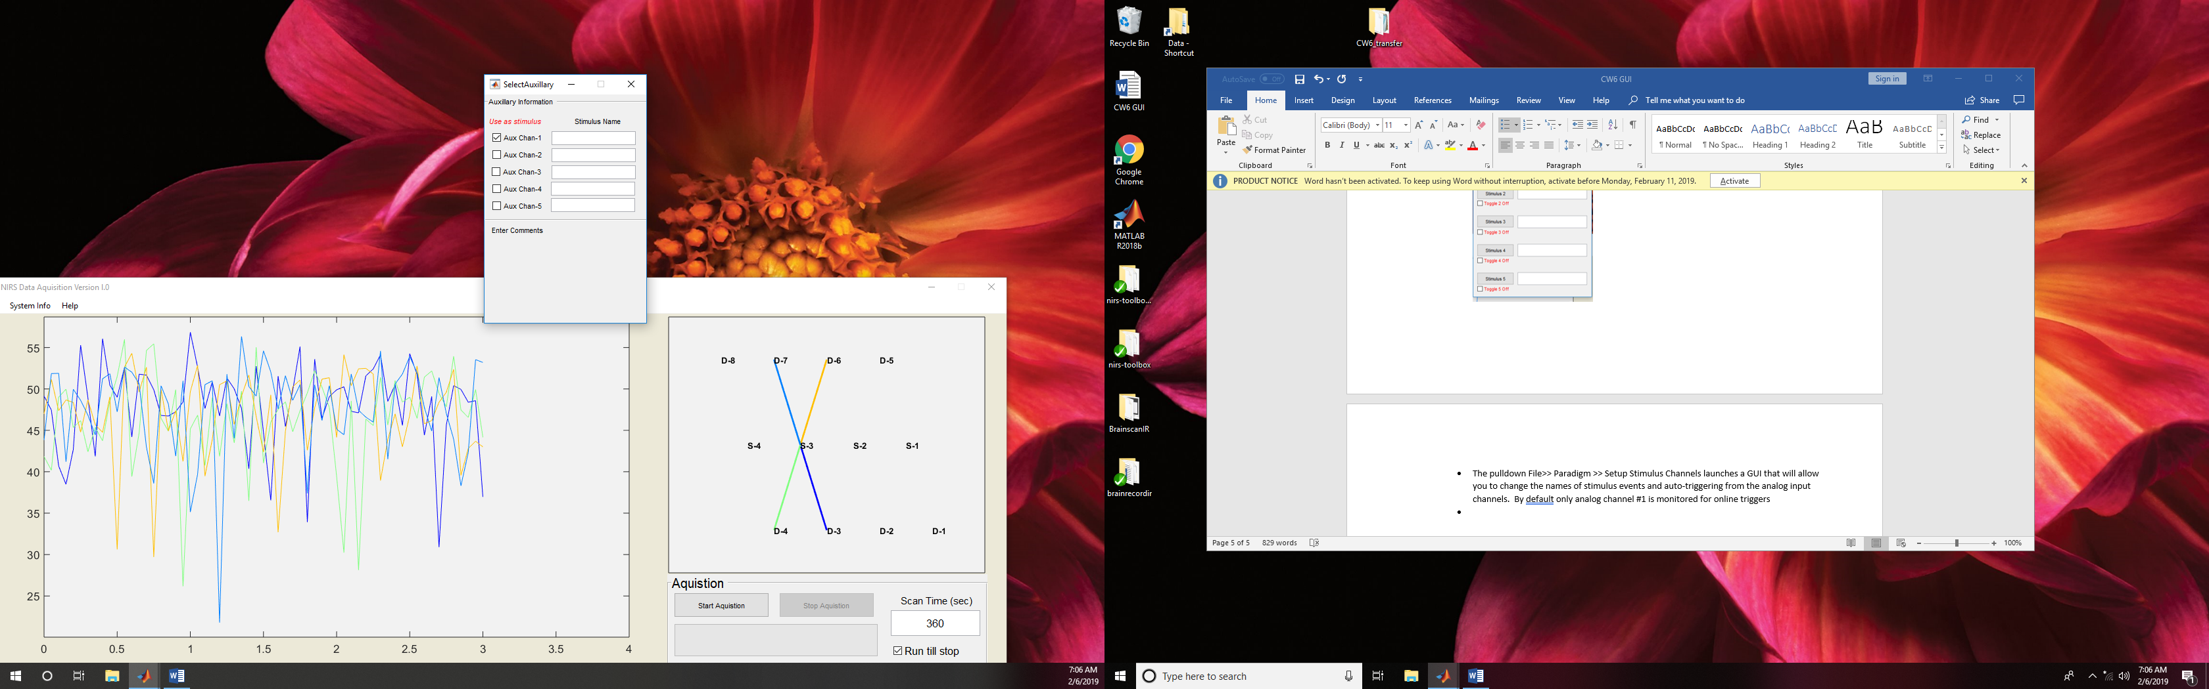

* The pulldown File>> Paradigm>> Link to EPRIME doesn’t work any more
* The pulldown File>> Subject >> Add comments will place comments in a text file in the subjects data folder
* File >> Export Data >> HOMER or Text file. Doesn’t work anymore
* Pulldown System Info >> System Config allows you to change the sample rate and override the default folder locations. Send DIO to sync will try to send a digital line using the LPT port synced with the start of acquisition. This is a bit obsolete since most computers don’t have a LPT port. You need a special cable to do this.
* 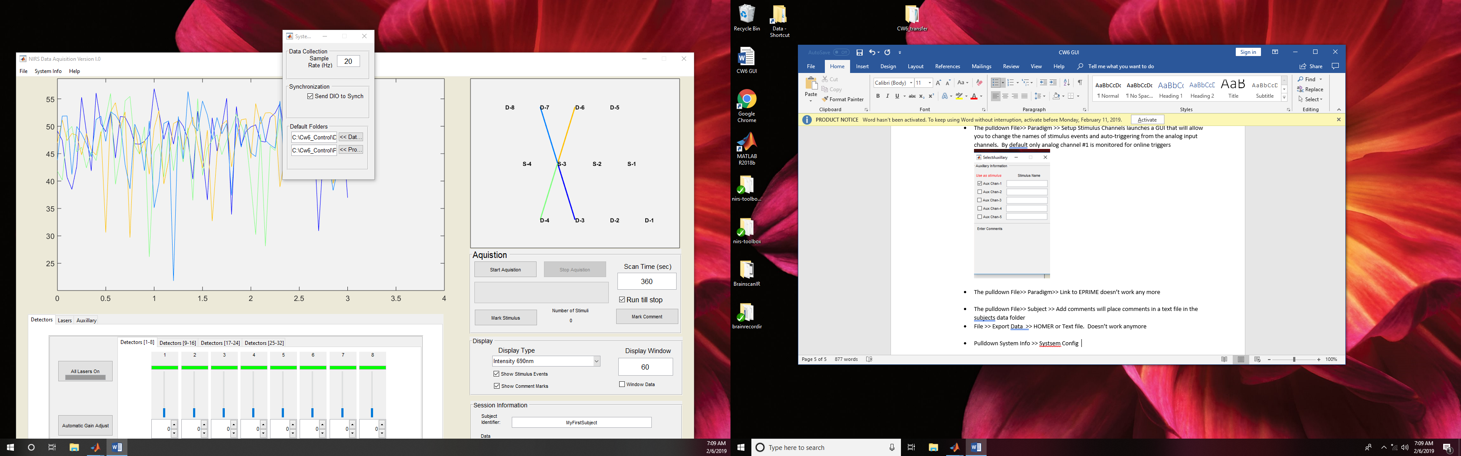
* The pulldown System Info >> Load/Save settings is useful to bring the detector gains and GUI back in the case of a system crash (happens far less often then it used to). Right before the aquistion starts, the Cw6 always saves a temp.sys file in the subject’s data folder. In the event of a crash, you can use the load setting control and point to this file to restore all the instrument settings including scan number etc. Save settings manually saves this same file.
* System Info >> real-time settings. This is deactivated at the moment

**Known Issues:**

* The system has trouble with autodetection of stimulus marks if the analog input starts high (e.g. the signal from Eprime was in the high state when the system is started). This can result in the display of a red stimulus mark for the whole data. The events in the file are fine, but the display is annoying. Turn off the “Show Stimulus Events” check box
* The real-time modules are deactivated. I broke them a few years back and haven’t tested in the newest release of the code
* There are come errors with richtext box controls in Matlab 2018 that I need to fix.
* The auto gain adjust could be a bit better